**Individual Project Report**

Philip Guy

Advanced Games Programming (CGP600)

**Figure 1:** *Spring Training 2009, Peoria, AZ.*

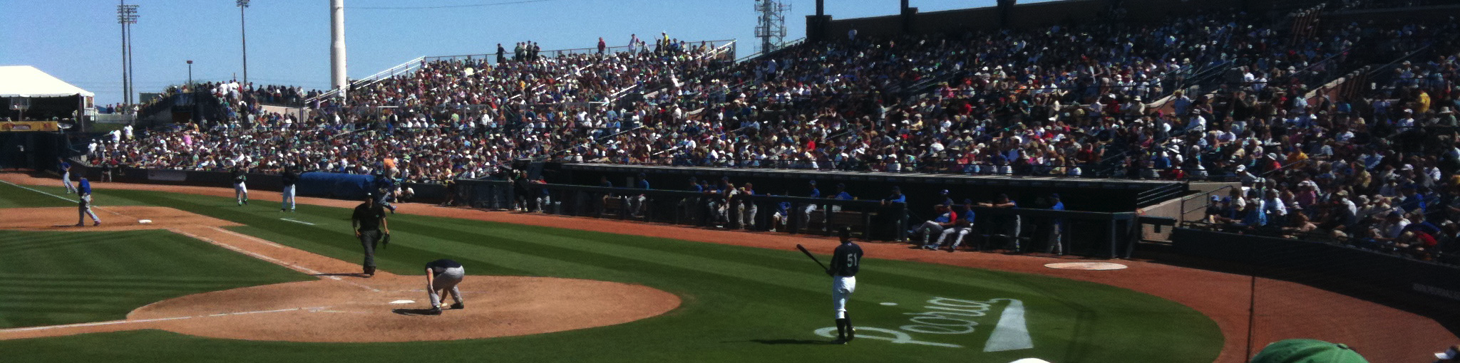

**Abstract**

In this sample paper, we describe the formatting requirements for content accepted to SIGGRAPH-sponsored events. The same format can be used for content ranging from a one-page Poster or Talk abstract, to a full-length Technical Paper. Please review this document even if you have submitted content to a SIGGRAPH sponsored event in the past, as some of the details have changed relative to previous years.

**CR Categories:** I.3.3 [Computer Graphics]: Three-Dimensional Graphics and Realism—Display Algorithms I.3.7 [Computer Graphics]: Three-Dimensional Graphics and Realism—Radiosity;

Keywords: radiosity, global illumination, constant time

1 The Basics: General Organization

Your content should have the following elements, in this order:

* title, author, and affiliation information
* abstract
* CR categories *
* keywords *
* body of the content
* bibliography

CR categories and keywords are required for Technical Papers and Technical Briefs, and optional for all other types of content. The LaTeX and Word templates faithfully implement the formatting specifications in this document, and the sample PDF documents can be used as visual examples for organization and layout.

*e-mail: [spencer@cs.washington.edu](mailto:spencer@cs.washington.edu)

**2 The Basics: Page Size and Columns**

Your content should be formatted on a US Letter (8.5 inches wide by 11 inches tall) page size. Please make sure you’re not working on an A4 page size. Page margins should be set at 0.75 inches on the right, left, and top, and one inch at the bottom. Two columns should be used throughout your content, except for the title, affiliations, and large images or tables which span both columns.

To summarize, here are the basic page specifications:

* page size: 8.5 inches wide by 11 inches tall (not A4)
* top margin: 0.75 inches
* right margin: 0.75 inches
* left margin: 0.75 inches
* bottom margin: 1 inch
* number of columns: 2
* column width: 3.33 inches
* column height: 9.25 inches
* column gutter: 0.33 inches

**3 The Basics: Typefaces, Paragraphs, and**

**Line Spacing**

Please use a serif (Times, Times New Roman, etc.) typeface for the body of your content. This serif typeface should be used for everything except the title of your content and section headings, which should be set in a sans-serif (Helvetica, etc.) typeface.

Your content should be prepared with 9-point text and 10-point line spacing. This includes the references section. Do not reduce the typeface size or the line spacing of any part of your content, in an effort to fit more into a specific number of pages.

All typefaces used in your content must be embedded in the PDF you create.

Paragraphs are prepared without any indentation on the first line, and with a 10-point-tall space between paragraphs.

Please do not add page numbers to your content. They will be added during production.

**4 The Basics: Title, Author, and Affiliation**

**Information**

The title, author, and affiliation information should be centered above the body of your content. The title should be set in a 14-point bold sans-serif typeface with 18-point line spacing. The author and affiliation information should be set in a 10-point serif typeface with 12-point line spacing.

The title should be appropriately capitalized. “All caps” is not appropriate. The following link provides assistance with appropriate capitalization:

<http://www.grammarbook.com/punctuation/capital.asp>

Affiliations should include your educational institution or employer’s name, and a valid e-mail address.

5 The Basics: Section Headings

Section headings should be set in an 11-point bold sans-serif typeface, on 13-point line spacing, and numbered – “1”, “2”, and so on. Subsection headings should be set in a 10-point bold sans-serif typeface and numbered – “1.1”, “1.2”, and so on. Subsubsection headings should be set in a 10-point italic sans-serif typeface and numbered – “1.2.1”, “1.2.2”, and so on. A 10-point-tall space should separate a section heading and the next paragraph.

6 Abstract, Keywords, and CR Categories

Your content should begin with an abstract of about 150 words, describing the work and its contribution to the field.

Authors of technical papers and technical briefs must also provide a list of user-generated keywords and a selection of CR categories, from the following link:

<http://www.acm.org/about/class/1998>

Authors of other types of content may include CR categories and keywords at their discretion.

7 ACM Rights Management Text

You are required to leave a blank space at the base of the left column on the first page of your content for the ACM rights management text. This blank space will be one column wide, and one inch tall for all types of content except technical papers accepted to our annual (SIGGRAPH and SIGGRAPH Asia) conference. In this case, the space must be 1.5 inches tall. (These technical papers are accepted as articles in the ACM “Transactions on Graphics” journal, and the rights management text is slightly different and occupies more space.)

8 Figures and Tables and Captions

Figures and tables can span one or both columns. Captions for figures should be centered underneath the figure. Captions for tables should be centered above the table.

Please use 9-point bold serif type for the caption title, and 9-point italic serif type for the caption text (both on 10-point line spacing).

**Table 1:** *A simple table.*

9 Citations and References

9.1 Citations

The SIGGRAPH citation format is the “author year” format [Pellacini et al. 2005]. The year is separated from the author by a single space [Yee 2000]. Two authors are separated by the word “and” [Parke and Waters 1996]. More than two authors are represented by the primary author and “et al.” [Levoy et al. 2000].

Multiple citations at a single point in the content are separated by semicolons [Levoy et al. 2000; Sako and Fujimura 2000].

When the last name of the cited author is part of the text, it may be omitted from the citation: “… as shown in Fedkiw et al. [2001], the coefficient remains…”

9.2 References

The reference list, or bibliography, must be unnumbered, alphabetized by the primary author’s last name, followed by the year of publication and other identifying information (article title, journal title, volume, number, etc.). Author names are arranged as “last name, initials.” The page number, if any, is the last piece of information in the reference.

The first line of each entry in the bibliography has no indentation. The second and successive lines has a 2em indentation. Journal, book, thesis, and conference proceedings titles are set in an italic serif type.

Please use 9-point serif type, with 10-point line spacing, for each entry in the bibliography, with a single blank line between each entry.

|  |  |
| --- | --- |
| 7C0 | Hexadecimal |
| 3700 | Octal |
| 11111000000 | Binary |
| 1984 | Decimal |

10 Third-Party Material

If you are using third-party material in your content – that is, material which you or your co-authors did not create – you need to clearly identify it as such in the material itself or in the content’s caption, as shown in Figure 2.

ACM’s policy on third-party material can be found at the following link:

<http://www.acm.org/publications/third-party-material>

11 “Artistic Images” and Copyright Transfer

ACM’s rights management policy mandates that if copyright is transferred to ACM, and authors wish to retain copyright of one or more of their own images or figures in the content, they can identify them as “artistic images” by including the author’s copyright notice in the image itself or in the caption.

(Please note that only technical papers and technical briefs have copyright transfer as an option. All other forms of content have permission and licensing options, but not copyright transfer.)

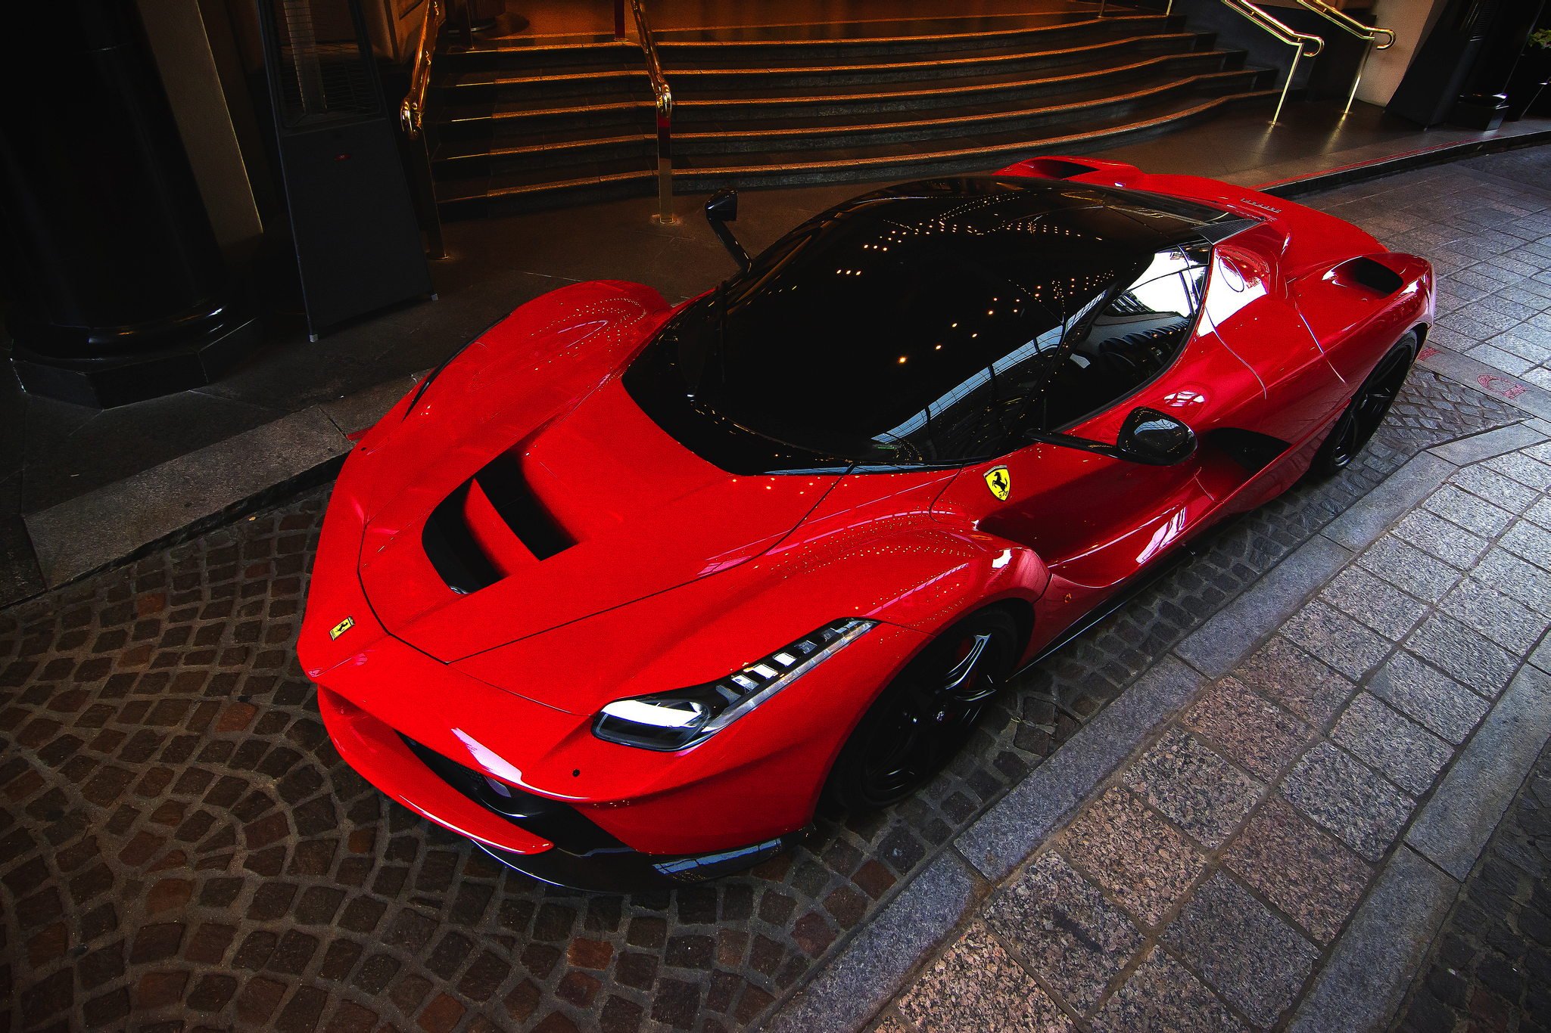

**Figure 2:** *Ferrari LaFerrari. Image courtesy Flickr user “gfreeman23.”*

12 Author-Prepared Versions of Final

Content

ACM’s rights management policy provides for author-prepared versions of final content to be made available on the author’s personal or employer’s web site for distribution.

The author is responsible for creating the article-specific notice and making it part of the PDF. The following is an example of such a notice. Yours will have the year, publication, and article DOI information specific to your final content.

(c) 2009 ACM. This is the author’s version of the work.

It is posted here by permission of ACM for your personal use. Not for redistribution. The definitive version was published in ACM Transactions on Graphics 28(3), August 2009. http://doi.acm.org/10.1145/1576246.1531329.

13 Application-Specific Notes

13.1 LaTeX

The “acmsiggraph” LaTeX class will faithfully implement the formatting specifications found in this document. Please look at the “template.tex” file that accompanies the LaTeX and BibTeX class files, noting these points:

* In order to leave the correct amount of space clear for the rights management text, you must do two things:

1. Use the proper parameter to the \documentclasscommand at the top of your source file: use “tog” for technical papers accepted to our annual events and published as TOG articles, and use “conference” for all other types of content. The parameter determines the amount of space left clear for the rights management text.
2. Use the \copyrightspacecommand. It should be placed immediately before the first section of your paper.

* If you do not use any parameter to the \documentclasscommand, and use the \copyrightspacecommand, you’ll end up with much more blank space than you want or need.
* Many authors like to have a large image - called a “teaser” image - after the title, author, and affiliation and before the body of the paper. There is a command - \teaser– which can be used to place such an image. (As has been done in this example document.) Under certain circumstances, the space left clear for the rights management text will move to the base of the right column on the first page. This is acceptable.
* Use the \keywordscommand to define your own keywords, and the \keywordlistcommand to prepare and print that block of text.
* Use the \CRcatlistenvironment and the \CRcatcommand to define the CR categories appropriate for your paper.

13.2 Microsoft Word

The “acmsiggraph.docx” file will faithfully implement the formatting specifications found in this document. An appropriately-placed column break is one way to leave the right amount of space for the rights management text.

14 Contact Information

If you have questions or suggestions regarding this document, please contact Stephen Spencer at “spencer@cs.washington.edu”.

Acknowledgements

To Robert, for all the bagels.

References

Agarwal, S., Mierle, K., and Others. Ceres solver.

<https://code.google.com/p/ceres-solver/>.

Anonymous, 1976. Planes of the head.

<http://www.planesofthehead.com/>.

Fedkiw, R., Stam, J., AND Jensen, H. W. 2001. Visual

simulation of smoke. In *Proceedings of SIGGRAPH 2001*,

ACM Press / ACM SIGGRAPH, E. Fiume, Ed., Computer

Graphics Proceedings, Annual Conference Series, ACM, 15–22.

Jobson, D. J., Rahman, Z., and Woddell, G. A. 1995. Retinex

image processing: Improved fidelity to direct visual observation.

In *Proceedings of the IS&T Fourth Color Imaging Conference:*

*Color Science, Systems, and Applications*, vol. 4,The Society

for Imaging Science and Technology, 124–125.

KARTCH, D. 2000. *Efficient Rendering and Compression for Full-*

*Parallax Computer-Generated Holographic Stereograms.* PhD

thesis, Cornell University.

LANDIS, H., 2002. Global illumination in production. ACM

SIGGRAPH 2002 Course #16 Notes, July.

LEVOY, M., PULLI, K., CURLESS, B., RUSINKIEWICZ, S., KOLLER,

D., PEREIRA, L., GINZTON, M., ANDERSON, S., DAVIS, J.,

GINSBERG, J., SHADE, J., AND FULK, D. 2000. The digital

michelangelo project. In *Proceedings of SIGGRAPH 2000*,

ACM Press / ACM SIGGRAPH, New York, K. Akeley, Ed.,

Computer Graphics Proceedings, Annual Conference Series,

ACM, 131–144.

PARK, S. W., LINSEN, L., KREYLOS, O., OWENS, J. D., AND

HAMANN, B. 2006. Discrete sibson interpolation. *IEEE*

*Transactions on Visualization and Computer Graphics* 12, 2

(Mar./ Apr.), 243–253.

PARKE, F. I., AND WATERS, K. 1996. *Computer Facial Animation.*

A. K. Peters.

PELLACINI, F., VIDIMčE, K., LEFOHN, A., MOHR, A., LEONE, M.,

AND WARREN, J. 2005. Lpics: a hybrid hardware accelerated

relighting engine for computer cinematography. *ACM*

*Transactions on Graphics* 24, 3 (Aug.), 464–470.

SAKO, Y., AND FUJIMURA, K. 2000. Shape similarity by

homotropic deformation. *The Visual Computer 16*, 1, 47–61.

YEE, Y. L. H. 2000. *Spatiotemporal sensistivity and visual*

*attention for efficient rendering of dynamic environments.*

Master’s thesis, Cornell University.